F223277@NUCFD.EDU.PK
|
DATA STRUCTURE LAB 1
22f-3277 mUHAMMAD TAHA

Q1
#include<iostream>
using namespace std;
//SORTING FUNCTION
void sort(int array[], int size)
{
int temp;
//BUBBLE SORT
for (int i = 0; i < size; ++i)
{
for (int j = 1; j < size; ++j)
{
if (array[j - 1] > array[j])
{
temp = array[j - 1];
array[j - 1] = array[j];
array[j] = temp;
}
}
}
}
//SEARCH FUNCTION
int search(int array[], int size, int search)
{
bool found = false;
for (int i = 0; i < size; i++)
{
if (array[i] == search)
{
return array[i];
found = true;
}
else
found = false;
}

//RETUNS FALSE VALUE 1000 IF NUMBER IS NOT FOUND
if (found == false)
return 1000;
}
int main()
{
const int size = 10;
int numArray[size];

for (int i = 0; i < size; i++)
{
cout << i << ". Enter 3 digit number: ";
cin >> numArray[i];

//CHECK FOR THREEE DIGIT NUMBER
while (numArray[i] <= 99 || numArray[i] >= 1000)
{
cout << "enter again 3 digit number: ";
cin >> numArray[i];
}
}

cout << "Press any key to sort array ";
system("pause");
//SORTING ARRAY
sort(numArray, size);
cout << "_______________SORTED ARRAY_____________\n";
for (int i = 0; i < size; i++)
{
cout << "[" << i << "]" << numArray[i] << endl;
}
cout << endl << endl;

int temp;
cout << "Enter a value to find in array: ";
cin >> temp;

if ((search(numArray, size, temp)) == 1000)
{
cout << "The entered number is not found";
}
else
{
cout << "The number you enterd is found ";
}

system("pause");
return 0;
}
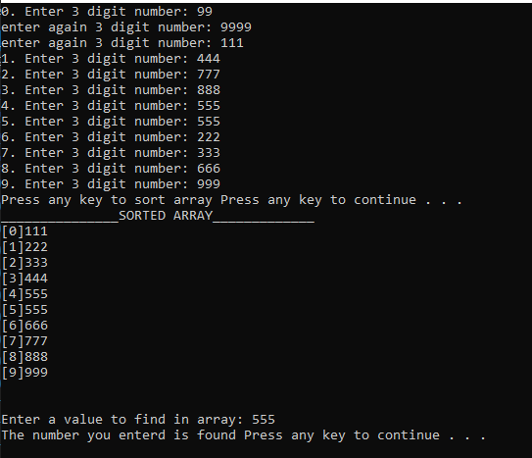

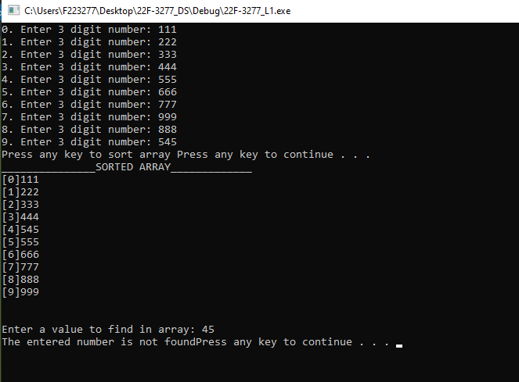

Q2
#include<iostream>
using namespace std;

//sees if element is in array
bool contains(int a[], int size, int value)
{
for (int i = 0; i < size; i++)
{
if (a[i] == value)
{
return true;
}
}
return false;
}
//input in array
void inputInArray(int a1[], int size1, int a2[], int size2)
{
cout << "Enter elements of array 1 : \n";
for (int i = 0; i < size1; i++)
{
cout << i + 1 << " : ";
cin >> a1[i];
}

cout << "\nEnter elements of array 2: \n";
for (int i = 0; i < size2; i++)
{
cout << i + 1 << " : ";
cin >> a2[i];
}

}
//counts common
int countCommon(int a1[], int a2[], int s1, int s2)
{
int commonCount=0;
for (int i = 0; i < s1; i++)
{
if (contains(a2, s2, a1[i]))
{
commonCount++;
}
}
return commonCount;
}
//prints common
void printCommon(int a[], int size)
{
cout << "Common elements array: ";
for (int i = 0; i < size; i++)
{
cout << a[i] << " ";
}
}

int main()
{
const int s1 = 8, s2 = 4;
int array1[s1], array2[s2];

inputInArray(array1, s1, array2, s2);

int commonCount = countCommon(array1, array2, s1, s2);

int array3[s1];

printCommon(array3, s1);

system("pause");
return 0;
}
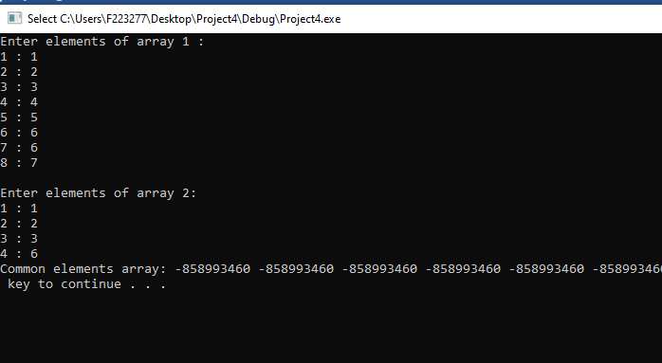

Q3
#include<iostream>
#include<fstream>
using namespace std;
int main()
{
float *floatPtr = new float[10];

//input in pointer
for (int i = 0; i < 10; i++)
{
cout << "Enter value " << i + 1 << " : ";
cin >> floatPtr[i];
}

//output
for (int i = 0; i < 10; i++)
{
cout << "\n[" << i << "] = " << floatPtr[i];
}

ofstream writeInFile;

//writing infile
writeInFile.open("file.txt");
if (writeInFile.is_open())
{
for (int i = 0; i < 10; i++)
{
writeInFile << floatPtr[i] << endl;
}
}
else
cout << "file is not open";

writeInFile.close();
cout << endl;
system("pause");
return 0;
}
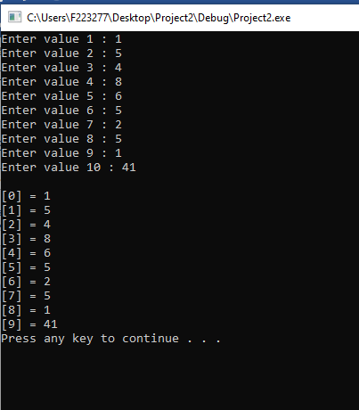
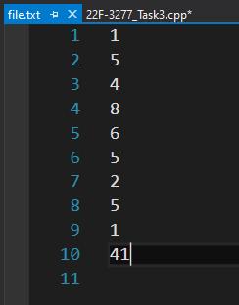

Q4
//Double Pointers
#include<iostream>
using namespace std;
bool primaryCheck(int* pointer)
{
for (int i = 2; i < *pointer / 2; i++)
if (*pointer % i == 0)
return false; //returns false if it's not Prime

return true; //returns true if it's Prime

}
int main()
{
int firstvalue = 5, secondvalue = 15;
int * p1, *p2, **p3, **p4;

p1 = &firstvalue; // p1 = address of firstvalue

p2 = &secondvalue; // p2 = address of secondvalue

p3 = &p1; // p3 = address of firstpointrer

p4 = &p2; // p4 = address of secondpointer

*p1 = 10; // value pointed by p1 = 10

*p2 = *p1; // value pointed by p2 = value pointed by p1

p1 = p2; // p1 = p2 (address of pointer is copied or not)
cout << "p1: " << p1 << endl;
cout << "p2: " << p2 << endl;
//Yes the address of P2 is copied to P1

p3 = p4; // p3 = p4 (check address of pointer is copied or not)
cout << "p3: " << p3 << endl;
cout << "p4: " << p4 << endl;
//Yes the address of P4 is copied to P3

*p1 = 20; // value pointed by p1 = 20

cout << "firstvalue: " << firstvalue << endl; // print fisrtvalue
cout << "secondvalue: " << secondvalue << endl; // print secondvalue

system("pause");

/*Passing pointer to a function primaryCheck() which tells that if the number is
Primary or not by returning true or false*/

int sum = firstvalue + secondvalue;
int* ptr;
ptr = &sum;

primaryCheck(ptr) ? cout << *ptr << " is a Prime Number\n\n" : cout << *ptr << " is not a Prime Number\n\n";

system("pause");

return 0;
}
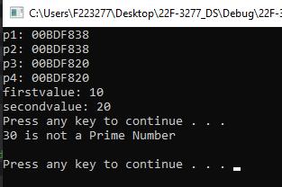

Q5
#include <iostream>
using namespace std;
//display function
void display(int** matrix, int* arr, int size)
{
cout << "Matrix is: \n";
for (int i = 0; i < size; i++)
{
for (int j = 0; j < arr[i]; j++)
{
cout << matrix[i][j] << " ";
}
cout << endl;
}
}
//input function
void input(int** matrix, int* arr, int size)
{
for (int i = 0; i < size; i++)
{
for (int j = 0; j < arr[i]; j++)
{
cout << "Enter for Row " << i + 1 << " : ";
cin >> matrix[i][j];
}
cout << endl;
}
}
int main()
{

int rows;
cout << "Enter number of rows: ";
cin >> rows;

//intializing row of 2d array
int** arr = new int*[rows];

int* cols = new int[rows];
for (int i = 0; i < rows; i++)
{
cout << "Enter number of elements for row " << i + 1 << " : ";
cin >> cols[i];
//intializing column of 2d array
arr[i] = new int[cols[i]];
}

//input in matrix
input(arr, cols, rows);
//displaying matrix
display(arr, cols, rows);
delete[]arr;
delete[]cols;
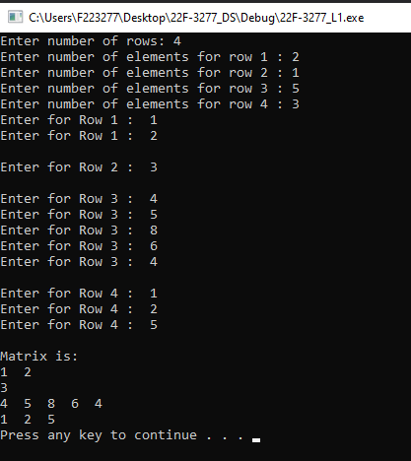
system("pause");
return 0;
}

